

Faculty of Engineering (Degree)
Semester – 1
Subject Name – Programming for Problem Solving
Subject Code – BE200104
Faculty Name – Ashwini Walake
Unit - 4: Control Structure in C

Decision making and Branching:
In C, programs can choose which part of the code to execute based on some condition. This ability is called decision making and the statements used for it are called conditional statements.
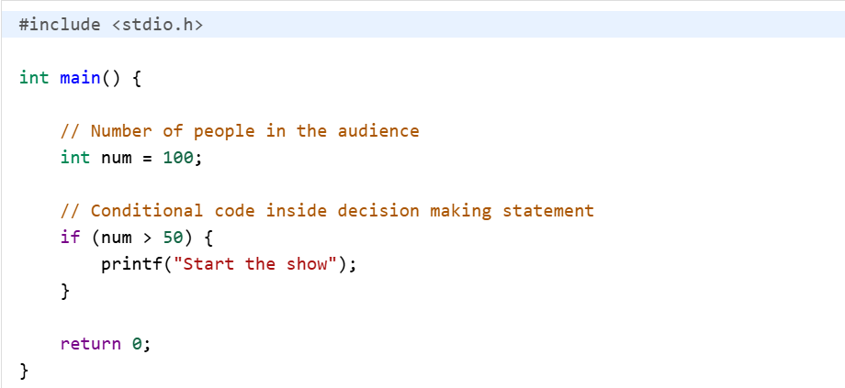
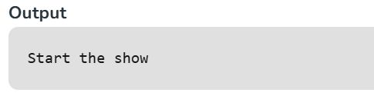
In the above program, the show only starts when the number of people is greater than 50. It is specified in the if statement (a type of conditional statement) as a condition (num > 50). You can decrease the value of num to less than 50 and try rerunning the code.

Types of Conditional Statements in C
In the above program, we have used if statement, but there are many different types of conditional statements available in C language:

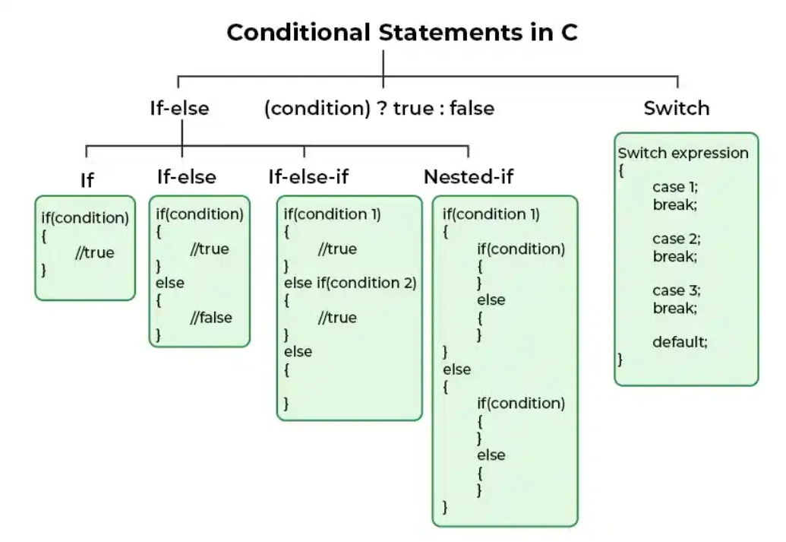
1. if in C
The if statement is the simplest decision-making statement. It is used to decide whether a certain statement or block of statements will be executed or not i.e if a certain condition is true then a block of statements is executed otherwise not.
A condition is any expression that evaluates to either a true or false (or values convertible to true or false).
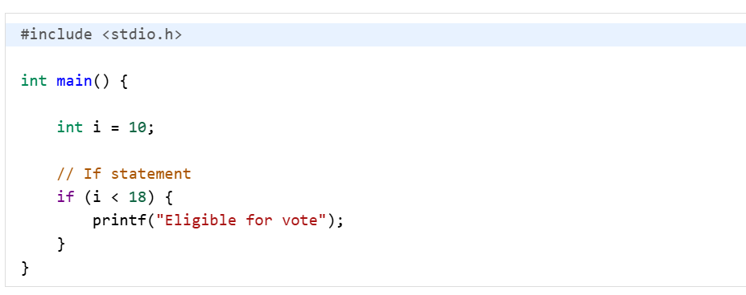
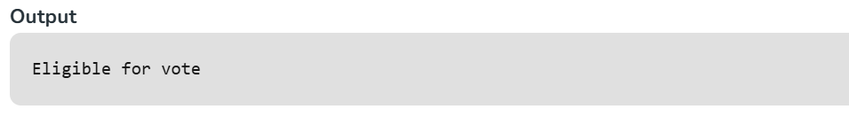
The expression inside () parenthesis is the condition and set of statements inside {} braces is its body. If the condition is true, only then the body will be executed.
2. if-else in C
The if statement alone tells us that if a condition is true, it will execute a block of statements and if the condition is false, it won’t. But what if we want to do something else when the condition is false? Here comes the C else statement. We can use the else statement with the if statement to execute a block of code when the condition is false. The if-else statement consists of two blocks, one for false expression and one for true expression.

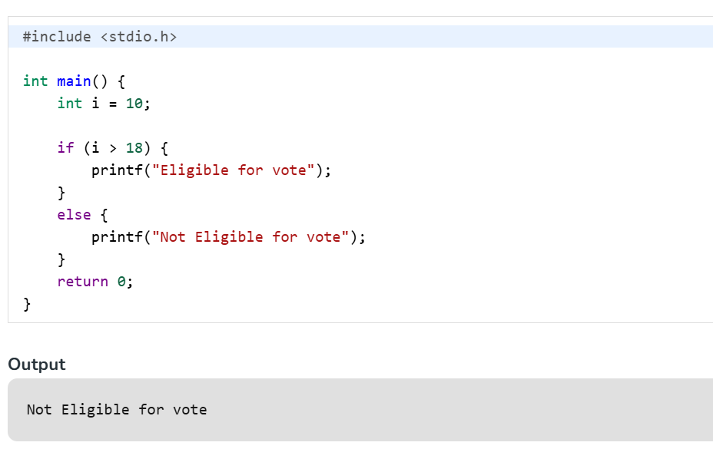
The block of code following the else statement is executed as the condition present in the if statement is false.
3. Nested if-else in C
A nested if in C is an if statement that is the target of another if statement. Nested if statements mean an if statement inside another if statement. Yes, C allow us to nested if statements within if statements, i.e, we can place an if statement inside another if statement.
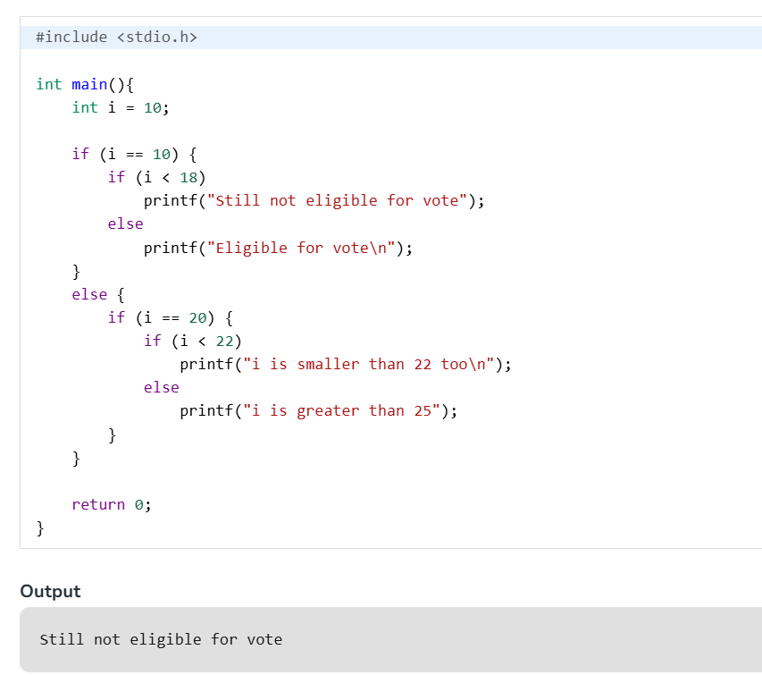
4. if-else-if Ladder in C
The if else if statements are used when the user has to decide among multiple options. The C if statements are executed from the top down. As soon as one of the conditions controlling the if is true, the statement associated with that if is executed, and the rest of the C else-if ladder is bypassed. If none of the conditions is true, then the final else statement will be executed. if-else-if ladder is similar to the switch statement.
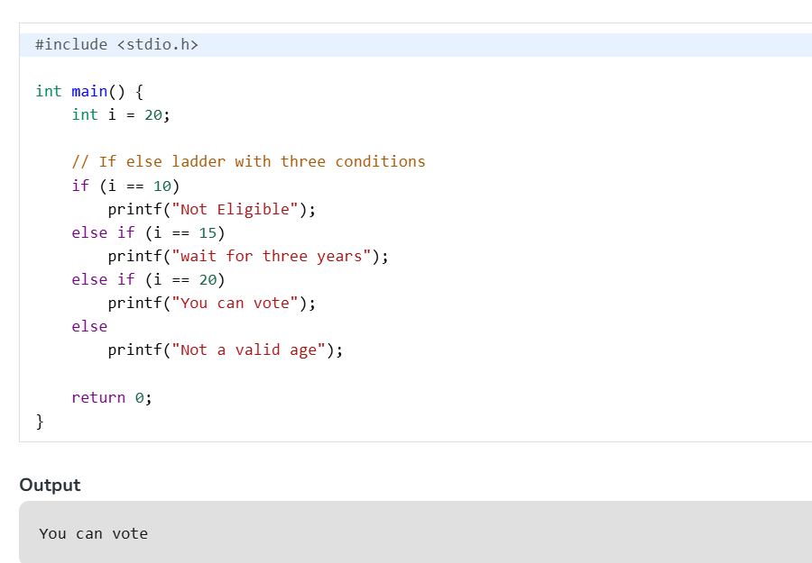

Conditional Operator in Programming
Conditional Operator, often referred to as the ternary operator, is a concise way to express a conditional (if-else) statement in many programming languages. It is represented by the "?" symbol and is sometimes called the ternary operator because it takes three operands.
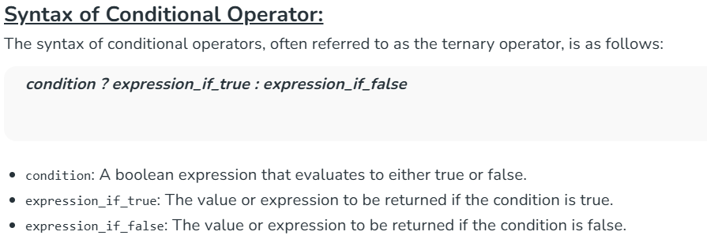
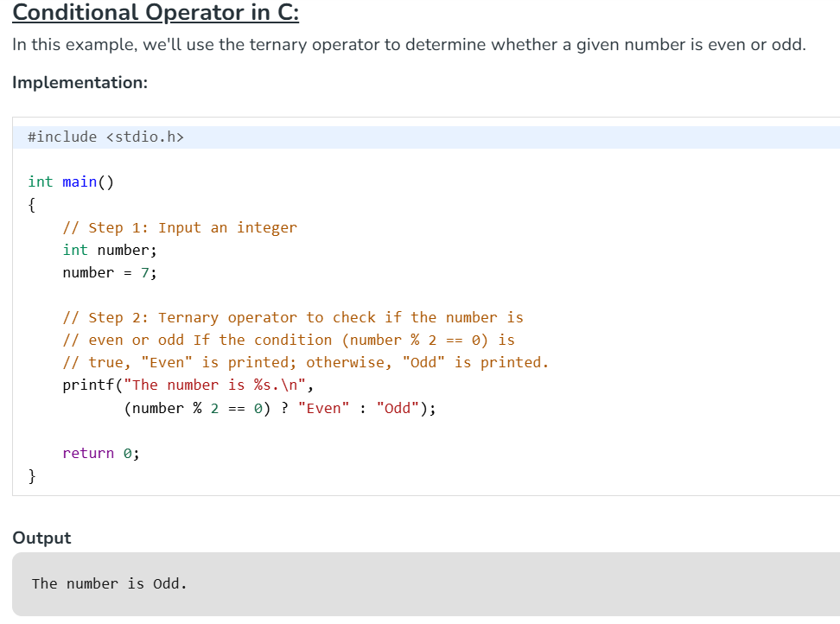

5. Switch Statement in C
The switch case statement is an alternative to the if else if ladder that can be used to execute the conditional code based on the value of the variable specified in the switch statement. The switch block consists of cases to be executed based on the value of the switch variable.
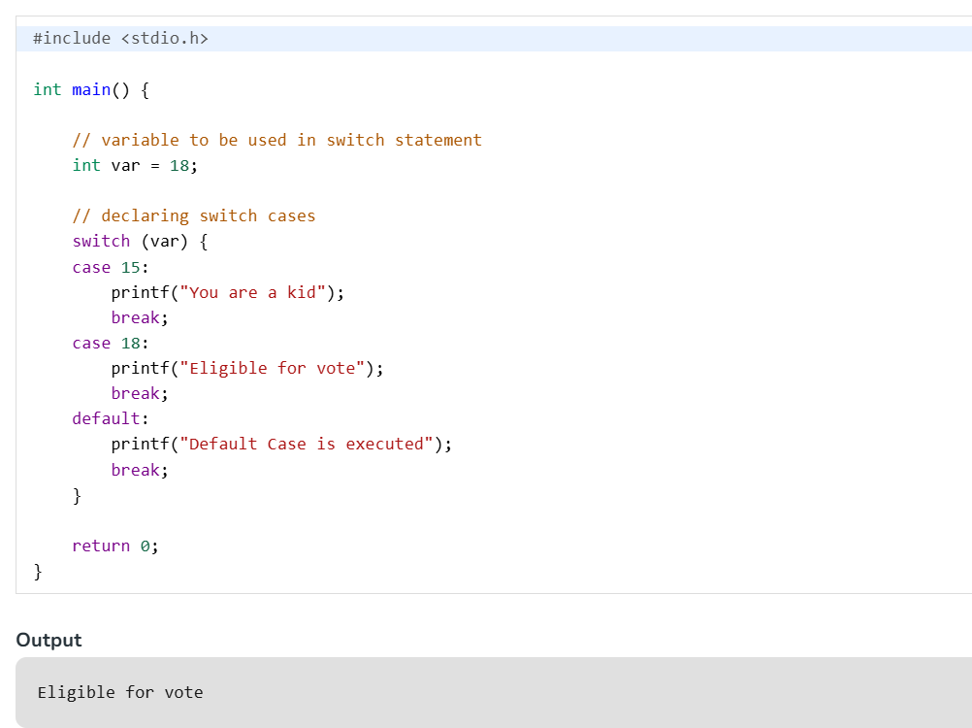
6) goto
The goto statement in C also referred to as the unconditional jump statement can be used to jump from one point to another within a function.
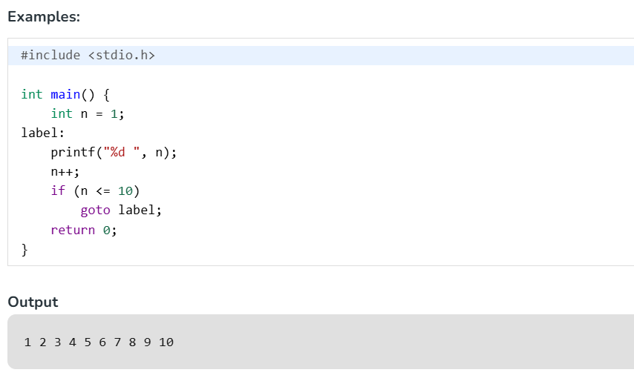
Decision-making and Looping
1)The While Statement:
The simplest of all looping structure in C is the while statement. The general format of the while statement is:
while (test condition)
{
body of the loop
}
Here the given test condition is evaluated and if the condition is true then the body of the loop is executed. After the execution of the body, the test condition is once again evaluated and if it is true, the body is executed once again.
This process of repeated execution of the body continues until the test condition finally becomes false and the control is transferred out of the loop. On exit, the program continues with the statements immediately after the body of the loop.
Example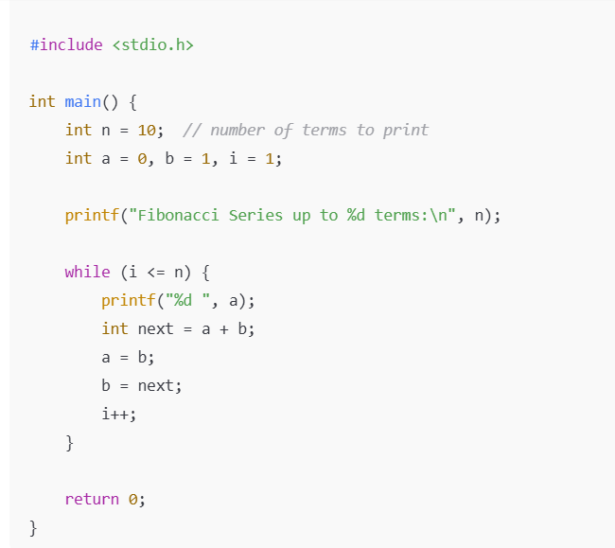
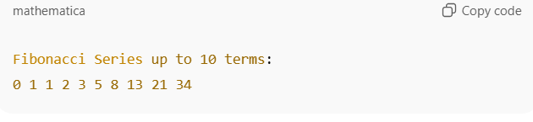
The Do while statement:
The do while loop is also a kind of loop, which is similar to the while loop in contrast to while loop, the do while loop tests at the bottom of the loop after executing the body of the loop.
Since the body of the loop is executed first and then the loop condition is checked we can be assured that the body of the loop is executed at least once.
The syntax of the do while loop is:
Do
{
statement;
}
while(expression);
Here the statement is executed, then expression is evaluated. If the condition expression is true then the body is executed again and this process continues till the conditional expression becomes false. When the expression becomes false. When the expression becomes false the loop terminates.
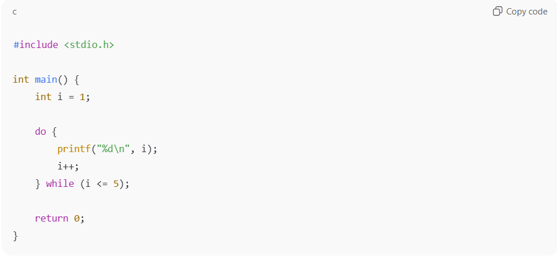
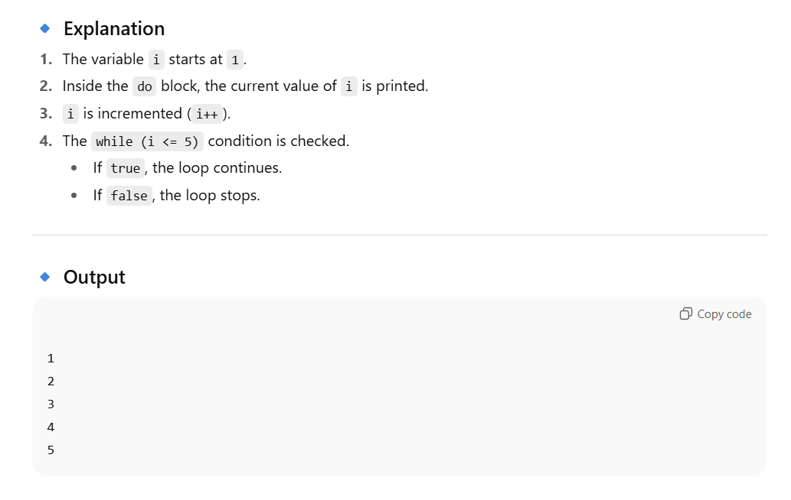
The Break Statement:
Sometimes while executing a loop it becomes desirable to skip a part of the loop or quit the loop as soon as certain condition occurs, for example consider searching a particular number in a set of 100 numbers as soon as the search number is found it is desirable to terminate the loop.
C language permits a jump from one statement to another within a loop as well as to jump out of the loop. The break statement allows us to accomplish this task.
A break statement provides an early exit from for, while, do and switch constructs. A break causes the innermost enclosing loop or switch to be exited immediately.
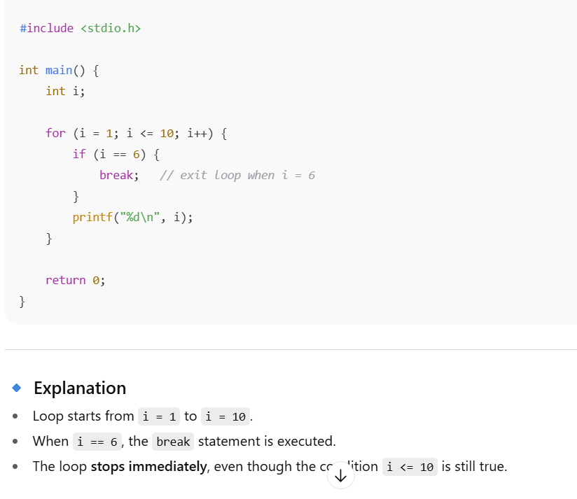
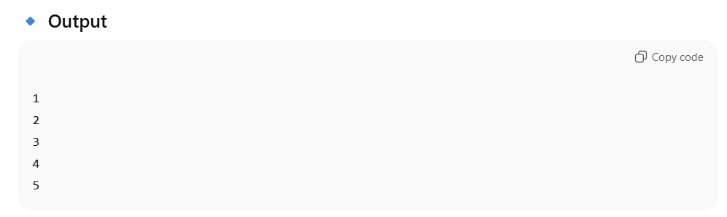
Continue statement:
During loop operations it may be necessary to skip a part of the body of the loop under certain conditions. Like the break statement C supports similar statement called continue statement. The continue statement causes the loop to be continued with the next iteration after skipping any statement in between. The continue with the next iteration the format of the continue statement is simply:
Syntax: Continue;
Consider the following program that finds the sum of five positive integers. If a negative number is entered, the sum is not performed since the remaining part of the loop is skipped using continue statement.
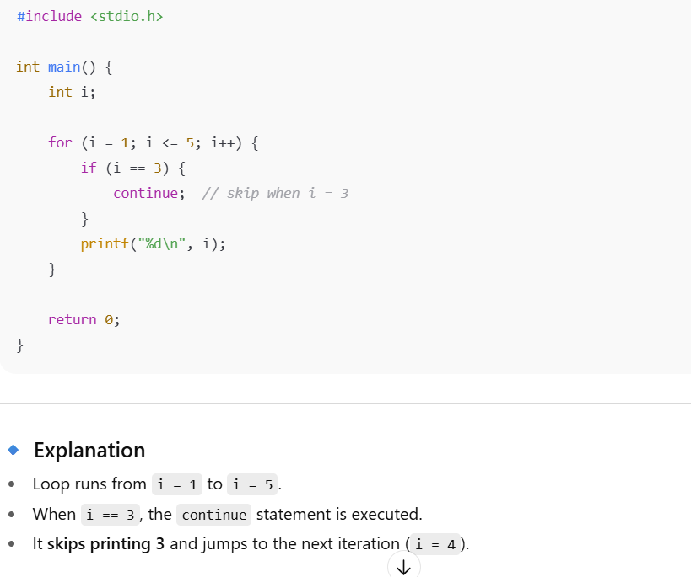
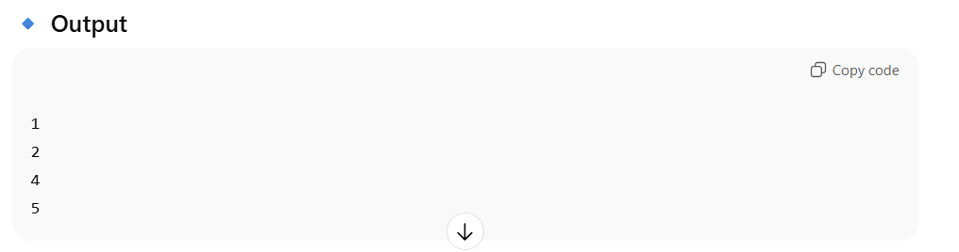

For Loop:
The for loop provides a more concise(code/ set of instructions without having to actually write it again and again) loop control structure. The general form of the for loop is:
for (initialization; test condition; increment)
{
body of the loop
}
When the control enters for loop the variables used in for loop is initialized with the starting value such as I=0, count=0.
The value which was initialized is then checked with the given test condition. The test condition is a relational expression, such as I < 5 that checks whether the given condition is satisfied or not if the given condition is satisfied the control enters the body of the loop or else it will exit the loop.
The body of the loop is entered only if the test condition is satisfied and after the completion of the execution of the loop the control is transferred back to the increment part of the loop.
The control variable is incremented using an assignment statement such as I=I+1 or simply I++ and the new value of the control variable is again tested to check whether it satisfies the loop condition.
If the value of the control variable satisfies then the body of the loop is again executed. The process goes on till the control variable fails to satisfy the condition.
Additional features of the for loop:
We can include multiple expressions in any of the fields of for loop provided that we separate such expressions by commas. For example in the for statement that begins
For( I = 0; j = 0; I < 10, j=j-10)
Sets up two index variables I and j the former initialized to zero and the latter to 100 before the loop begins. Each time after the body of the loop is executed, the value of I will be incremented by 1 while the value of j is decremented by 10.
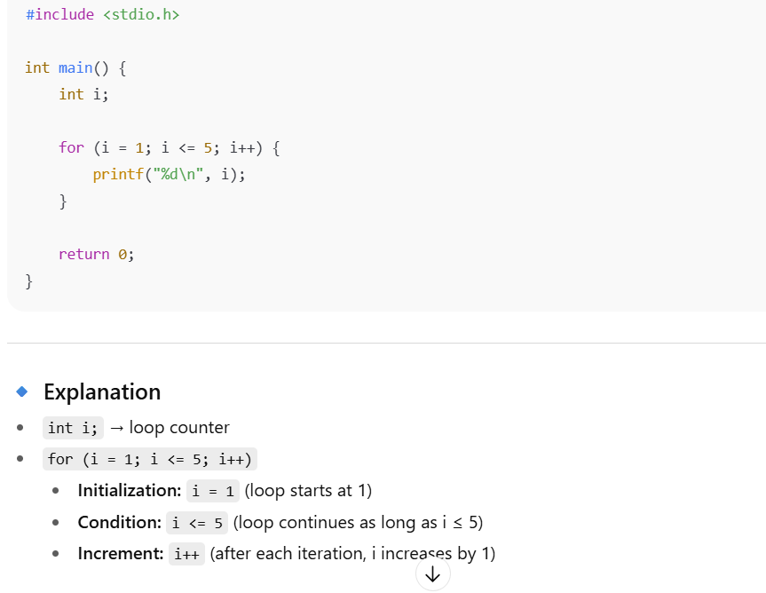
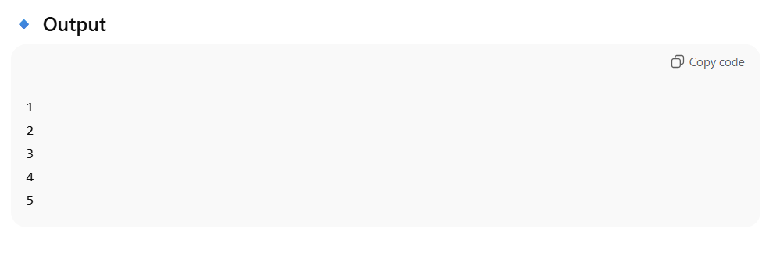

Pattern Programs in C
Printing patterns using C programs has always been an interesting problem domain. We can print different patterns like star patterns, pyramid patterns, etc. in C language. These problems require the knowledge of loops and if-else statements

1. Right Half Pyramid Pattern
The right-half pyramid is nothing but a right-angle triangle whose hypotenuse is in the right direction. We can print the right half pyramid pattern using numbers, alphabets, or any other character like a star (*)

#include <stdio.h>
int main() {
int rows = 4;

// This loop for traverse
// pyramid from top to bottom
for (int i = 0; i < rows; i++) {

// Inner loop for printing
// character in each rows
for (int j = 0; j <= i; j++) {
printf("* ");
}
printf("\n");
}
return 0;
}
OUTPUT:
*
* *
* * *
* * * *

2. Left Half Pyramid Pattern
The Left Half Pyramid looks like a right-angled triangle with its hypotenuse facing the left. We can also print this pattern using a character, alphabets, or numbers.
int main()
{
int rows = 5;

// This loop for traverse pyramid from top to bottom
for (int i = 0; i < rows; i++)
{

// This loop for printing leading whitespaces
for (int j = 0; j < 2 * (rows - i) - 1; j++)
{
printf(" ");
}

// This loop for printing * character in each row
for (int k = 0; k <= i; k++)
{
printf("* ");
}
printf("\n");
}
return 0;
}

3. Full Pyramid Pattern
The Full Pyramid pattern looks similar to the Equilateral triangle. We can see this as the combination of the Left Half and Right Half pyramids patterns. The following example demonstrates how to print this pattern using alphabets, numbers, or a star (*).
#include <stdio.h>

int main()
{
int rows = 5;

// This loop to print all rows
for (int i = 0; i < rows; i++)
{

// Inner loop 1 to print white spaces for each row
for (int j = 0; j < 2 * (rows - i) - 1; j++)
{
printf(" ");
}

// Inner loop 2 to print star (*) character for each row
for (int k = 0; k < 2 * i + 1; k++)
{
printf("* ");
}
printf("\n");
}
return 0;
}

